Neural Network
The word, Neuron, captured from human brain.
Designed to learn from patterns and generalize from data
Ex
Recognizing cats in photos
Converting speech to text

Biological neuron

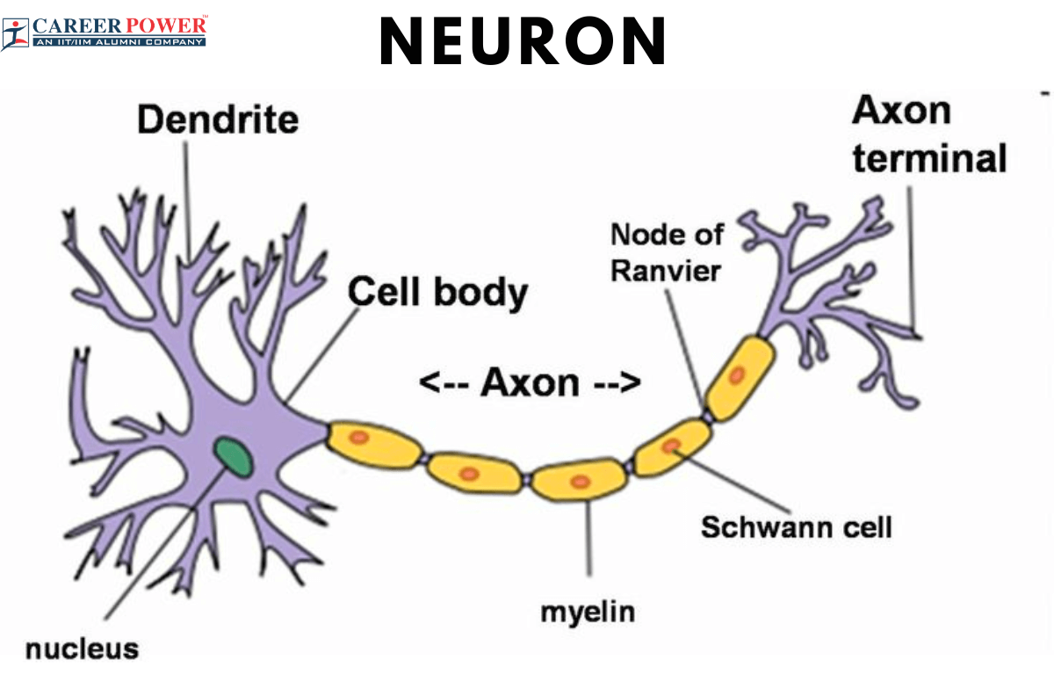

Biological Neuron receives signals through Dendrites, process them – send the results through Axon to the other neuron
Artificial neuron – it mimics the above process, receives the input signal – weight their importance, and produce the output signal

NN applications
- Speech recognition – alexa, google assistant
- Image recognition – unlocking your mobile with your face
- Video classification – youtube’s automatic tagging system

Deep Learning – Neural network with many layers

Perceptron
It is simplest form of neural network
It helps to make a decision based on multiple inputs

Ex – you have to visit some XYZ restaurant
- Reviews - 2
- transportation - 3
- Distance from home - 4
- Cost of food - 5
- …
- …..

Our decision depends on several factors –
Each factor matters differently – distance can be less vs cost can be more OR vice-versa..
From above example – show how a perception works
It takes multiple inputs, assigns a weight/importance and combines them to make a decision

Mathematical form of perceptron is
Cumulative Input = w1x1+w2x2+w3x3+………..+wnxn+b

Xn=inputs
Wn = weight / importance
b=bias, a constant

vector and matrix representation

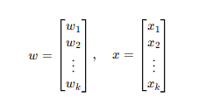

Dot product of vectors

Transpose of w
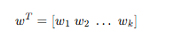

Dot product w^T.x
w1x1+w2x2+w3x3+………..+wnxn+b

ex
w=[0.4.0.3,0.3] and x = [5,2,3]
w^T.x = 0.4*5 + 0.3*2 + 0.3*3 = 3.5

3.5 is the cumulative input to the perceptron

Step function – / decision rule
After receiving cumulative input, the perceptron applies step function to decide final output

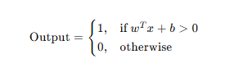
From above restaurant ex –
If cumulative input > 0 decide to go to restaurant
If cumulative input <=0 stay at home

Classification vs regression
- Receives features
- Hidden layers – intermediate representations
- Output layer – produces final prediction

Classification networks have multiple output neurons – one per class
Regression networks have a single output neuron for continuous values
Ex
Classification – predicting digit (0-9) 10 output neurons
Regression – predicting house price 1 output neuron

Predicting loan approval based on income, age, credit card scope how many input neurons?
3

Image – 28x28 image 784 input neurons

RGB channels
In a neural network, RGB channels represent the three color layers of an image (red, green, and blue) that the network processes as a three-dimensional tensor.

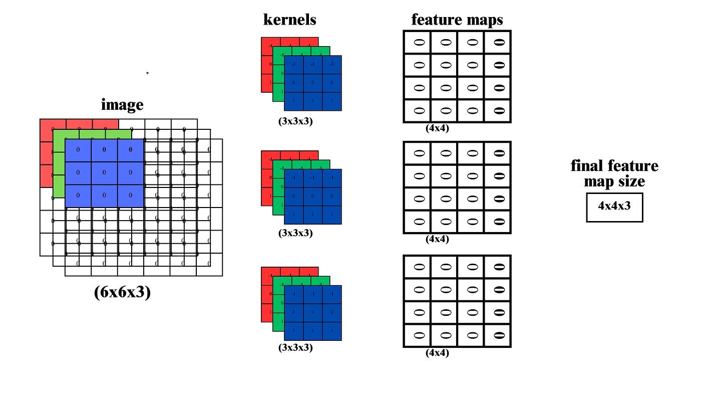
Each pixel has 3 values (R,G,B)
For 18x18 image 18x18x3 =972 input neurons

Outputs of neural network
Classification
Softmax function


Converts raw scores into probabilities
Ensures all outputs sum to 1
Used when predicting multiple classes
Ex
Digit recognition

Sigmoid
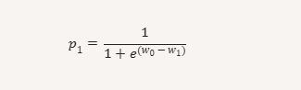

Sigmoid is derived from softmax with two classes
Output is between 0 and 1
Ex
Email spam detection

Network
Input layer – receives numeric features
Hidden layer – learn intermediate patterns
Output layer – produces prediction
Weights and biases – learnable parameters
Activation functions – non-linearity

All inputs need to be in numeric

Text – one hot encoding or word embeddings convert words to vectors
Images – pixel intensity are numeric (0-255)
Categorical data Red, green, blue – [1,0,0],[0,1,0],[0,0,1]

Challenges
Image data high dimensional, noisy , variability, modeling challenges
Image noise -

Structure of a single neuron

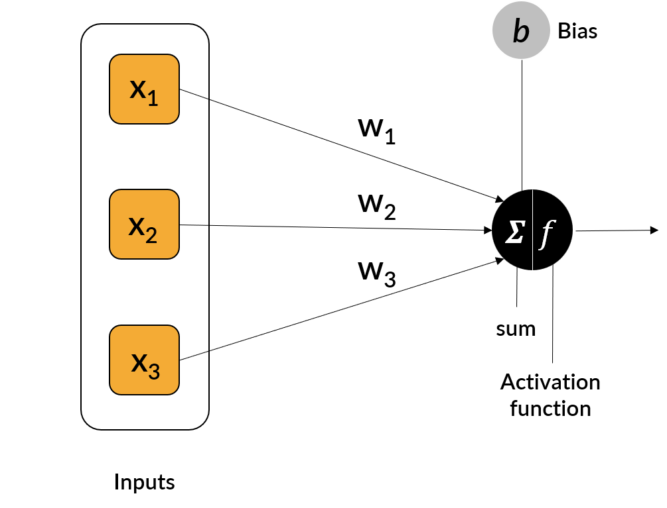
X1,x2,x3 are different features of dataset for ex – predicting house prices
X1 could be size of the house
X2 could no.of rooms
X3 could be location
Each input is multiplied by a weight – w1,w2,w3

After weighting the inputs, neuron sums them all up and adds bias

Z= w1x1+w2x2+w3x3+b
Input | Descr | Value | Weight
X1 |  | 2 | 0.8
X2 |  | 3 | 0.3
X3 |  | 8 | 0.9
Bias |  |  | 1.2

Z = you will get a value = ???
Lets say above you got a value of 12.7
Cumulative input to the neuron is 12.7
Now this number passes through an activation function
Assignment – do a scenario of job interview

From above
After appplyting activation function, we get output of the neuron,
Y = f(z)

Sigmoid function
f(z) = 1/1+e^-z
output is between 0 and 1
ideal for binary classification

TanH (hyperbolic tangent)
f(z) = tanh(z)
output ranges from -1 to +1
centered around 0, it helps model negative and positive influences equally
ex – sentiment analysis, reviews

ReLU (rectified linear unit)
f(z) = max(0,z)
- Simple and efficient – output is z if z>0 otherwise 0
- Good for deep learning models
- Ex – image recognition,

Choosing the right activation function
- Type of the problem (classification vs regression)
- Nature of output (binary, multi-class, continuous)
- Depth of network
- Need for non-linearity

Parameters and Hyper-parameters in neural network

Parameters
These are internal variables that network learns during training –
- Weights strength of connection between two neurons
- Biases allow shifting the activation threshold so the neuron can fire even if inputs are small
ex
Digit recognition
- Weights learn which pixels matter most to identify a number for ex 3 vs 5
- Biases help adjust the threshold so the neuron can trigger correctly even if image is not proper

Hyperparameter

Setting prior to training
Parameters are what model learns on its own, hyperparameters are the rules we define prior to training begins
Hyperparameter | Descr | Real time scenario
No.of layers | Depth of network | Adding more filters in photo editing
Neurons per layer | Width of each layer | More neurons – more capacity to detect patterns
Learning rate | Step size for weight updates | Too high – overshoot, too low=slow learning
Epochs | No.of full passes through data | More epochs = more learning but can overfit

Symbols encounter in neural network equations

W weight matrix -- W 1,2 – weights between layer 1 and layer 2
b – bias term -- b3,1 : bias for neuron 1 in layer 3
x – input vector – input features
y - actual label – ex cat, dog, etc
p – predicted probability – output after softmax
h – hidden layer output – h2, 1 – output of neuron 2 in layer 1

? learning rate us too high or too low
- Learning rate decides how big a step the model takes when adjusting weights
Too high – overshoot
- Loss fluctuates, never settles
Too low – crawl
- Training takes forever

Weights and biases are imp
- Decides how much each input contributes to final prediction
  - Weights – scale input imp
  - Bias – shift / decision threshold

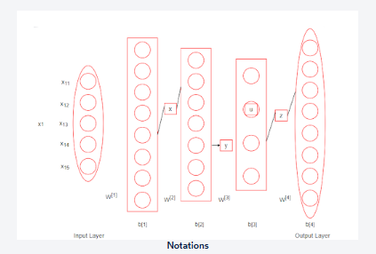

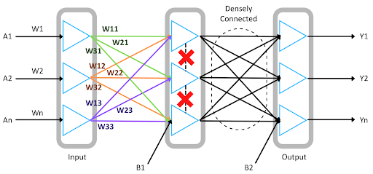

Assumptions

Layered and sequential structure
- Neurons are grouped into layers: input, hidden, output
- Data flow forward from one layer to the next

No interaction within a layer
Every neuron in a layer connects to every neuron in next layer

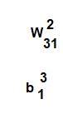
- Weight from neuron 1 in layer 1 to neuron 3 in layer 2
- Bias of neuron 1 in layer 3

Layer-1 might use ReLU to extract features, while output layer uses softmax to produce probabilities

